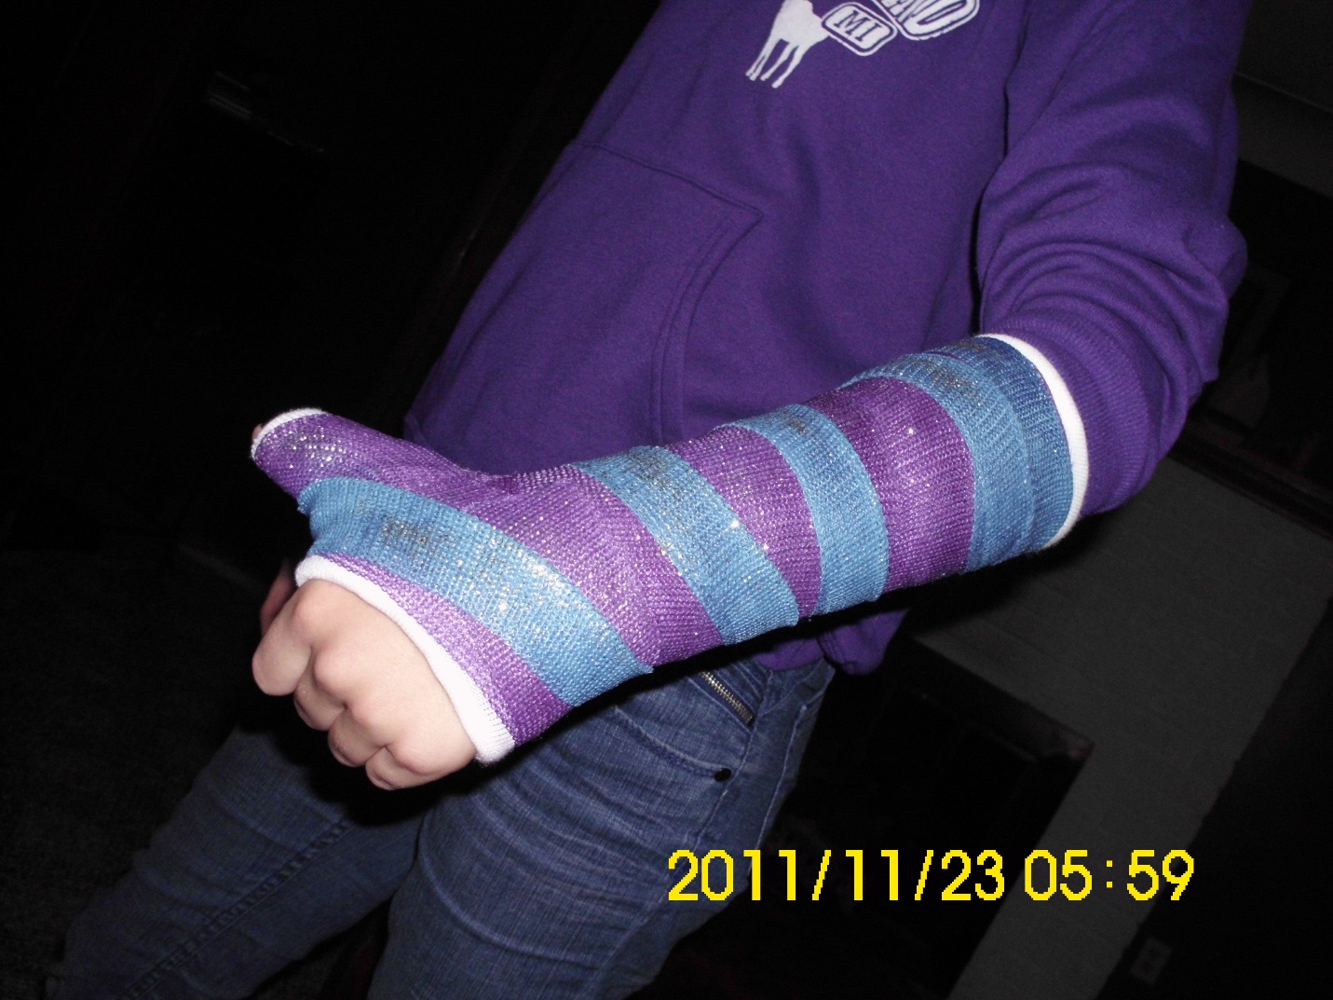

Janelle, whose major is music with an emphasis on Piano performance, severely broke her wrist playing touch football. Her wrist was in a cast for 8 weeks.
Discuss the state of Janelle’s finger, hand, and arm motor maps before the accident. And then make conjectures about the changes that would have happened in her motor maps by the time cast came off. Which aspects of the motor maps would have changed the most, do you think, and why?

